eCivil Registration Administrator User Manual
| version 1.0 |

Table of Contents
1 Heading 1 4
2 Heading 2 4
3 How to log on to system 5
3.1 Installing Fire Fox 7
3.2 Installing Sinhala/Tamil language kit 9
3.3 Installing printer plugging for FireFox browser 10
3.4 Logging to system 11
3.4.1 Possible errors and messages while logging in to system. 13
3.5 How to log out form the system 15
4 How to use the system 16
4.1 Admin Task 16
4.1.1 Create User 16
4.1.2 Search Users 25
4.1.2.1 Search by role and district 25
4.1.2.2 Search by user ID 25
4.1.2.3 Editing a user 26
4.1.2.4 Delete a user 26
4.1.2.5 Activate and inactivate a user 26
4.1.2.6 Add or remove user location 26
4.1.3 Add Divisions 27
4.1.3.1 Adding new district 27
4.1.3.1.1 Inactivate / Activate District 28
4.1.3.1.2 Possible errors and messages while adding a new district. 28
4.1.3.2 Adding a new DS division. 31
4.1.3.2.1 Possible errors and message while adding ds division 34
4.1.3.3 Adding a new court 35
4.1.3.3.1 Possible errors and message while adding court to the court list. 37
4.1.3.4 Adding a new Birth/Death Division 38
4.1.3.4.1 Activate /Inactivate a birth/death division 42
4.1.3.4.2 Possible errors and messages while adding birth/death division. 42
4.1.3.5 Adding a new Marriage registration division. 43
4.1.3.6 Adding a new Grama Niladhari division. 44
4.1.4 Manage Assignments 45
4.1.4.1 Search Assignments 45
4.1.4.2 Edit registrar details 48
4.1.4.3 Edit current assignments 49
4.1.4.4 Add new assignments 50
4.1.4.4.1 Add new assignment (Birth/Death) 50
4.1.4.4.2 Add new assignment (Marriage) 51
4.1.5 Add Registrars 52
4.1.5.1 Possible errors and messages while adding a new registrar 54
4.1.6 View Events 55
4.1.7 Index Records 55
4.1.7.1 Possible errors and messages while indexing records 56
4.1.8 Search Registrars 57
4.1.8.1 Search by PIN number 58
4.1.8.2 Search by name 58
4.1.8.3 Possible errors and messages while searching 58
4.1.9 Report Generation 59
4.1.9.1 Steps for generating reports. 60
4.1.9.2 To view the generated report 60
4.1.9.3 populate statistics. 60
4.1.9.4 Possible errors and messages while generating reports. 60
4.2 User Preference 62
4.2.1 User Preference 62
4.2.1.1 Changing preferred language. 62
4.2.2 Change Password 62
4.2.2.1 Possible errors while changing password. 63
5 Icons 65
6 Special Tools 67
6.1 Using date picker 67
6.2 Using time picker 67
6.3 Using data tables 68
7 Valid Inputs 69
7.1 Serial number 69
7.2 Date 69
7.3 Time 69
7.4 Certificate Number 69
7.5 NIC 69
7.6 PIN 70
7.7 Passport 70
70

Heading 1

Heading 2

How to log on to system

- You can logging to the eCivil registration system by entering following link to your web browser .
https://192.168.1.8:9080/
- Then following page will be displayed.
- Go through that page and make sure that your computer have mandatory requirements for using the eCivil registration system.
- Follow are the mandatory requirements for using eCivil registration system
    - FireFox 3.6.x or higher web browser
    - sinhala/ tamil language kit
    - printer plugging for printing documents
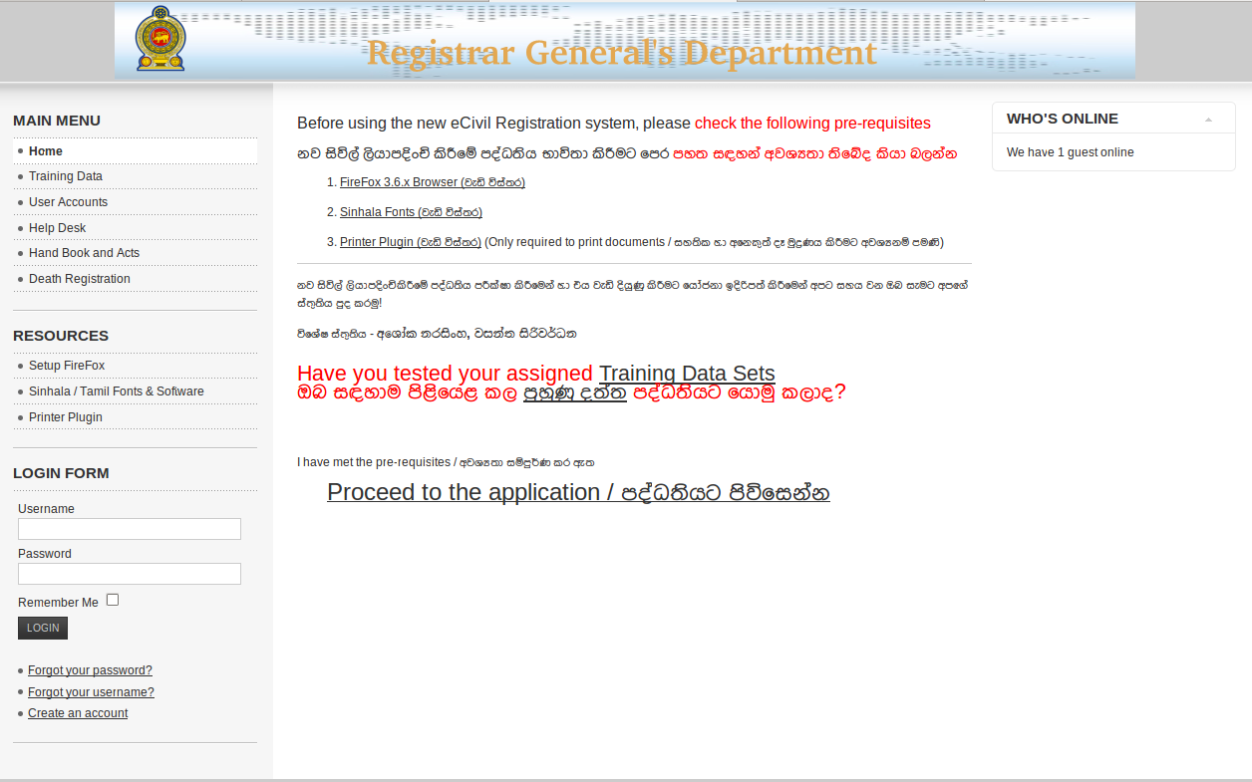Figure 3.1: welcome page

Installing Fire Fox

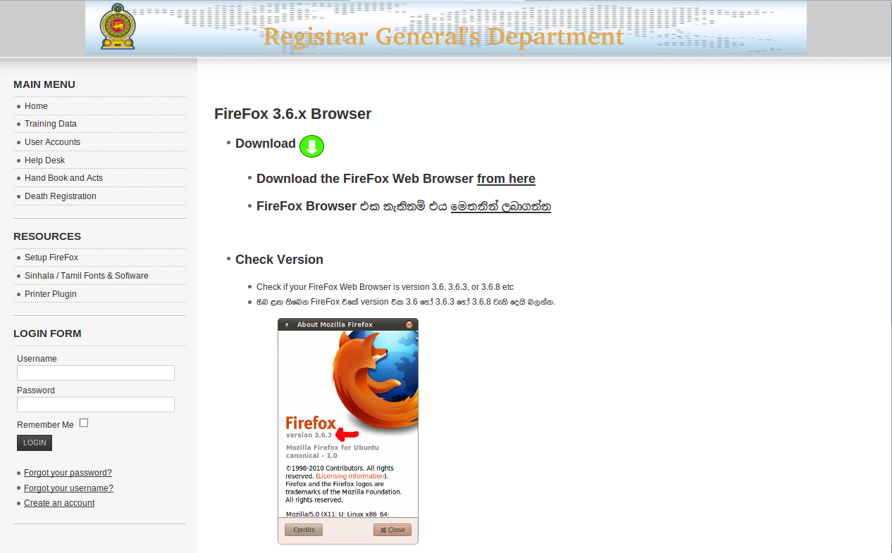Figure 3.1.1: installing fire fox

Installing Sinhala/Tamil language kit

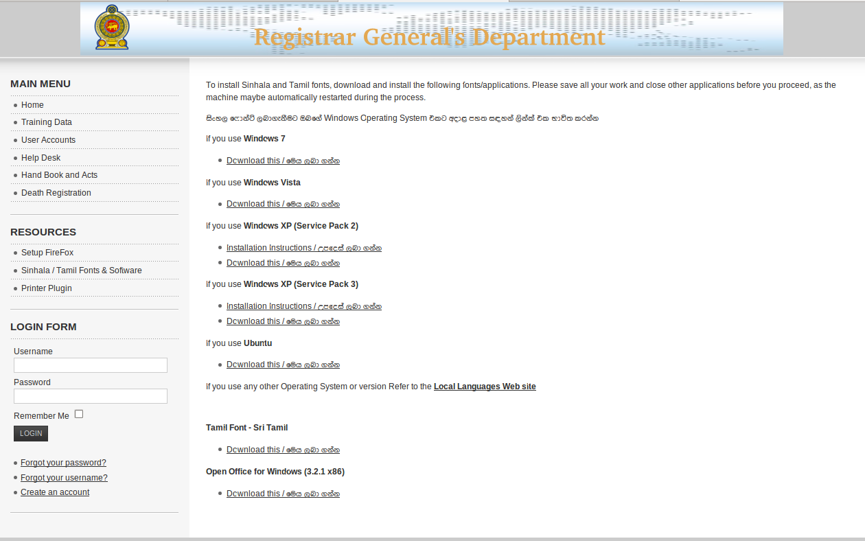Figure 3.2.1: installing language kit

Installing printer plugging for FireFox browser

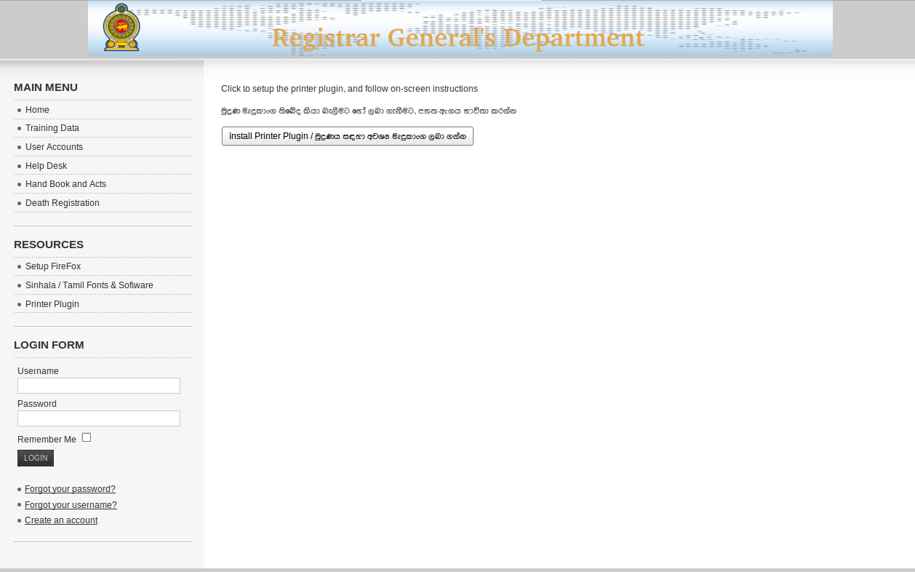Figure 3.3.1: install printer plugging

Logging to system
- After make sure that your computer have mandatory system requirements click “Proceed to application ” for proceed to the system.
- After successfully proceed follow page will be displayed used provided user name and password for logging to the system.
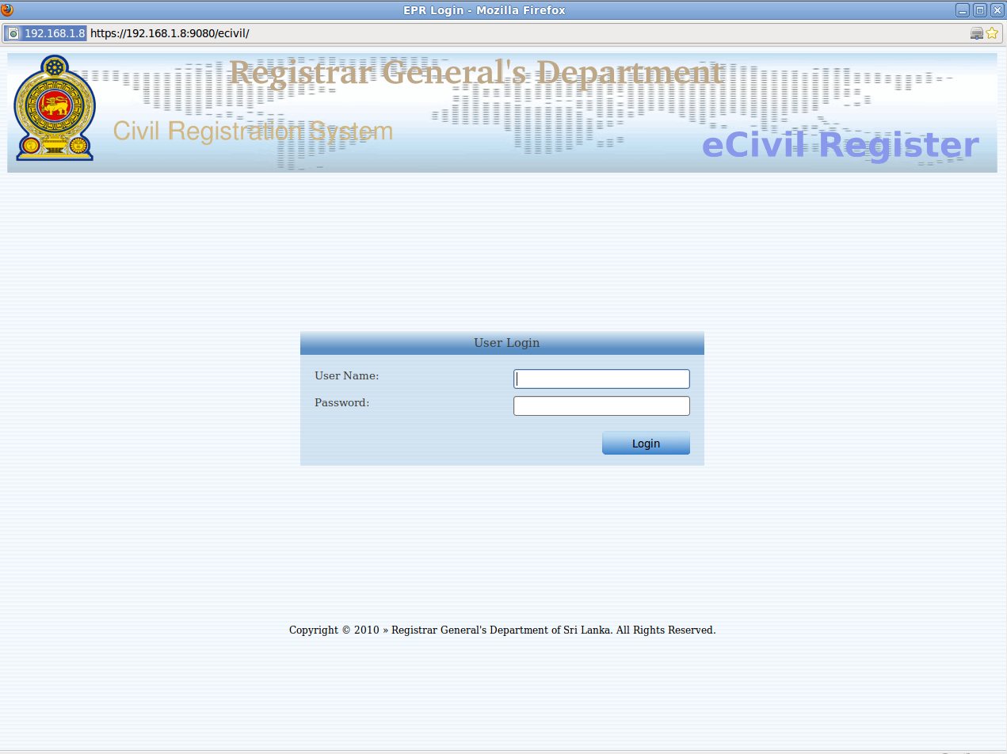Figure 3.4.1: logging to system

After successful logging user's user id and users primary location will be displayed on the top right corner of the title.

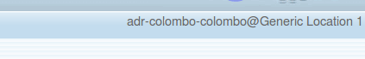Figure 3.4.2: user id and location

Possible errors and messages while logging in to system.
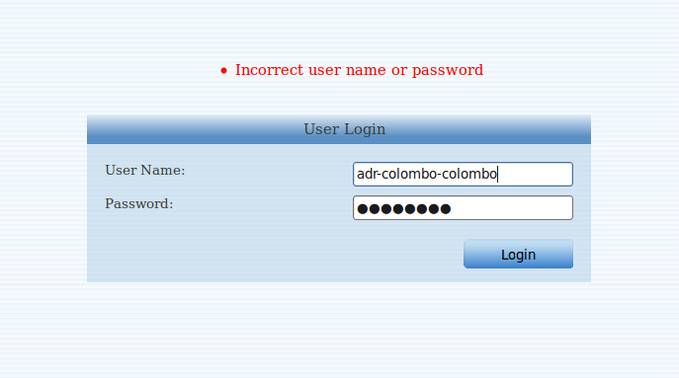Figure 3.4.1.1: incorrect user name or password
Reason for error :
User has entered incorrect user name OR password
How to avoid :
- Check again your user name and password
- If you forget user name or password contact system administrator for requesting a new password.

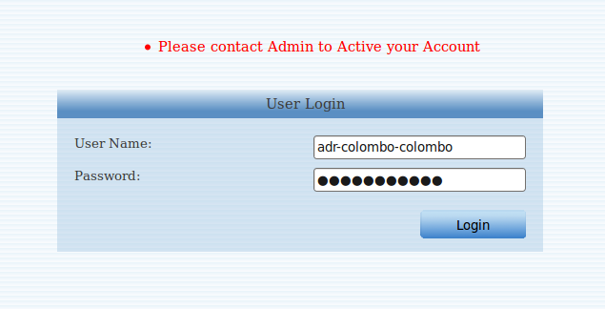Figure 3.4.1.2: inactive user account
Reason for error : User account has been inactivated . Follow are some of possible scenarios that this can happen.
- Administrator deactivated the account .
- User has failed to enter correct user name and password in 3 consecutive attempts.

How to avoid : Contact system administrator for re activate user account.

How to log out form the system

It is advisable to logout form the system when ever you are not using the system.
To logout click “log out ” button at the bottom of left menu.

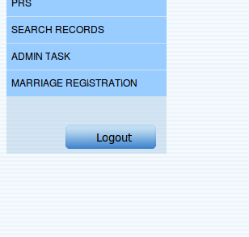Figure 3.5.1: log out form the system

How to use the system

Admin Task

Create User
Under this section Administrator can create system user with several user privileges.
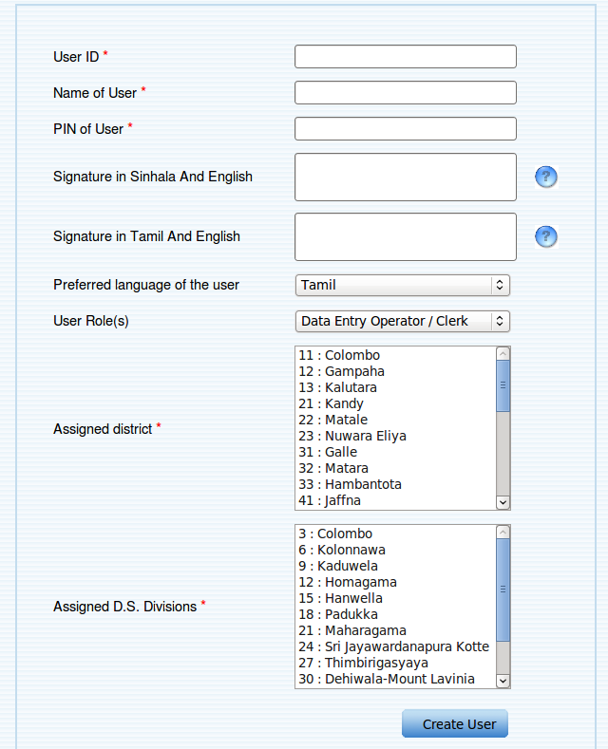Figure 4.1.1.1: create new user

User ID :
user's unique identification for the system and it will be used for identify the user uniquely .
Example user ID : deo-colombo-colombo
It is better to follow a good naming convention but is not mandatory. And filling this field is mandatory.

Name of the user's :
User's actual name . A mandatory field.

PIN of user :
User's PIN number . Only PIN numbers are allowed .If user is not registered on PRS add user to the PRS before try to create user. This is a mandatory field.

Signature in Sinhala/English :
User's signature in sinhala and english languages.
Example signature:
එස්. ආර්. පියසිරි / S. R. Piyasiri\
අතිරේක දිස්ත්‍රික් රෙජිස්ට්‍රාර් / Additional District Registrar\
කොළඹ / Colombo

Signature in Tamil / English :
User's signature in tamil and english langaages.
Example signature:
S. R. Piyasiri in ta/ S. R. Piyasiri \
Additional District Registrar in ta/ Additional District Registrar \
Colombo in ta / Colombo

Preferred language of the user:
User's preferred language for using the system and this can be either Sinhala or Tamil or English.

User's Role ;
Assign a new user a role ,user's are assigning permission based on the assigned role. And follow are the available roles for the user.

Data Entry Operator / Clark
System Administrator.
Registrar General
Assistant Registrars General / Provincial Registrar
Additional Registrars General / District Registrars
Data Entry Operator / Clark
Additional District Registrars.

Assign District and Assign DS divisions.
Every user's ( except System administrator user ) is allocated to a particular district and ds division .

Assign district and ds divisions for DEO/Clark
Can select only one district and one DS division for this user .
Assign district and ds division for ADR
Can select only one district and one DS division for this user .
Assign district and ds division for DR .
Can select only one district and all the DS divisions inside that district will be added automatically.

Assign district and ds division for ARG
Can select multiple district
To assign multiple district click “ctrl” key on the key board.
All the ds divisions inside the selected district will be added automatically.

Assign district and ds division for RG
No need to select a district or a ds divisions this user is automatically assign all the ds divisions and districts.

Note : for system administrator users no district or ds division is available.

- After filled all the required details click “Create user ” button to add the user.
- After successful add follow page will be displayed .

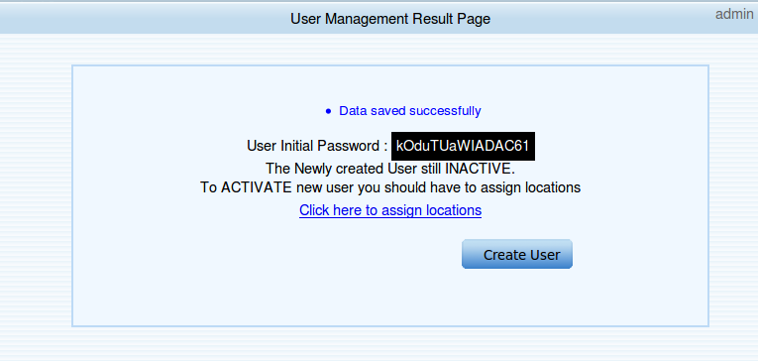Figure 4.1.1.2: successfully adding of a user
- In that window it will displayed a password for newly created user.
- And administrator must be assign location for the user to be an active user so click the given lick to make the user active
- If administrator want to add a new user click “ Create User” button.
- After clicking the link administrator will be forward to following page.

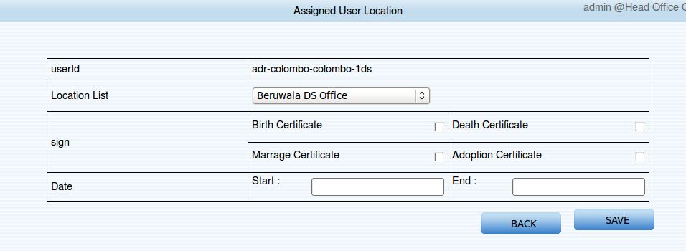Figure 4.1.1.3: assign locations for the user

- Select a location from the list .
- To allow certificate signing permission on selected location select the permission.
- And fill start and end date .
- To save the data click “Save” or to discard changes click “Back”.
- After successful adding following page will be displayed.

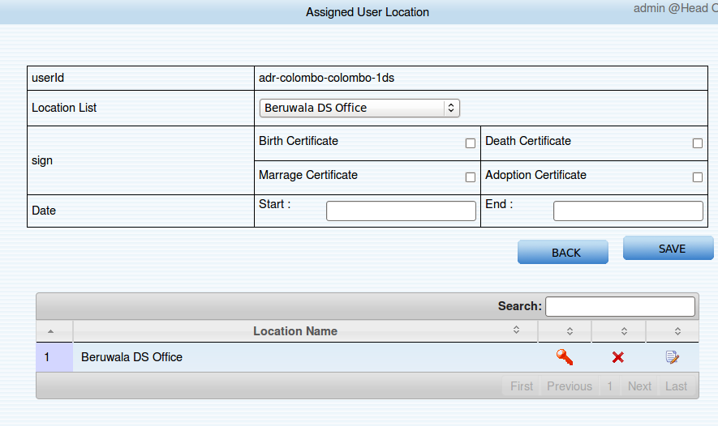Figure 4.1.1.4: successfully added location
- The newly added location is added to the table .
- To add more location select another location and click “Save”.
- Now user is successfully created and now that user can be login to the system with provided user name and password.

Search Users
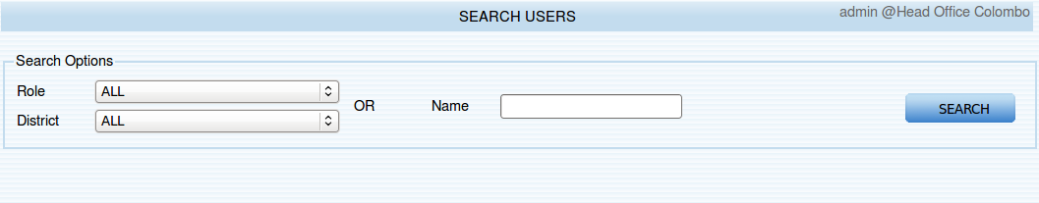Figure 4.1.2.1: searching user

Search by role and district
Steps for searching
- Select a role
- Select a district
- Click “Search”

Search by user ID
- Insert full name or part of the name
- click “Search”
- After successful search results will be shown as follows.
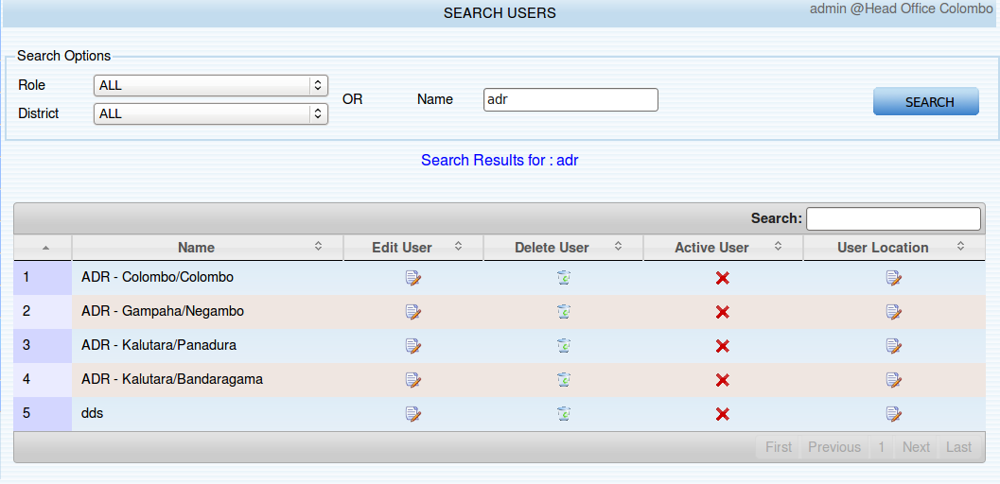Figure 4.1.2.2.1: searching results

Editing a user
- To edit a user click on the edit icon it will forward to the user edit page .
- User ID is not editable.
- Edit relevant data and click “Edit” for edit.
- You can change user's password as well .

Delete a user
- To delete click on the delete icon
- After successful deletion table will be loaded with the remaining users

Activate and inactivate a user
- To inactivate a user click “wrong” icon to inactivate user
- If the user is currently inactivate a “correct” icon will be displayed . To activate click on that icon.

Add or remove user location
- To edit users location click on the location icon .
- The current location are available on the table .
- The primary location is denoted with a “Red key “ icon.
- Other are displayed with a “Yellow key” icon.
- To set a another location as primary key click on the “Yellow key” icon.

Add Divisions

Adding new district
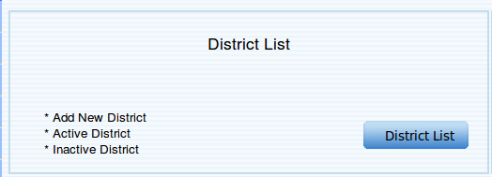Figure 4.1.3.1.2: adding a new district
- To add a new district click on “District List”.
- Follow page will be displayed after clicking above button.

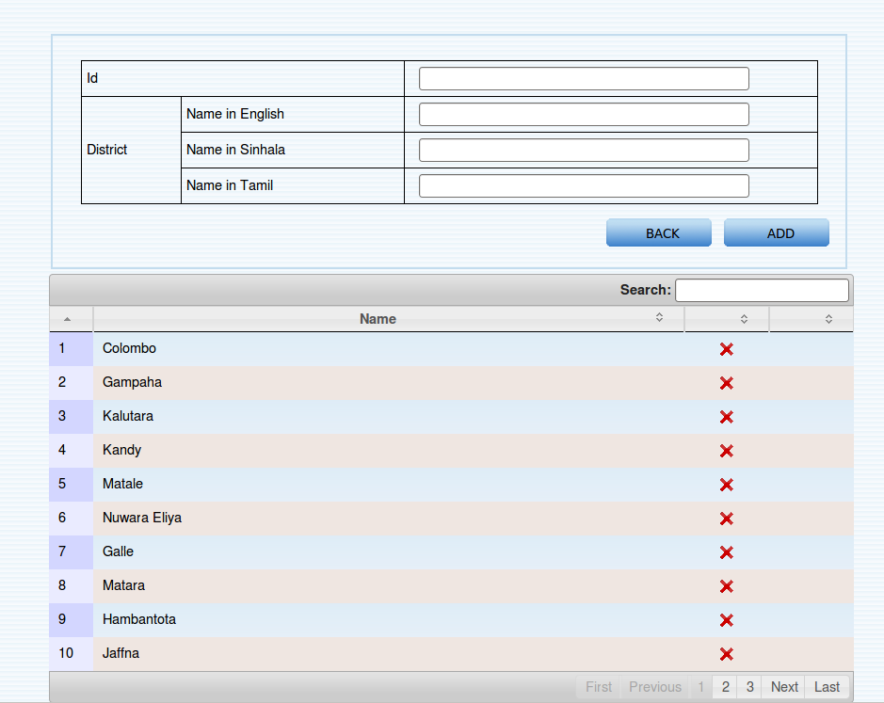Figure 4.1.3.2: insert a new district
Steps for adding a new district

- Give a unique id for the district ( only numbers are allows ).
- Fill district name in English and Sinhala and Tamil.
- Click “Add”
- After successful add the newly created district will be added to the table.

Inactivate / Activate District

- “Wrong” symbol denote that they are already active and to inactivate click on the symbol after successful inactivation symbol will be change to “correct” icon.
- To activate a inactivate district do vise versa of the above step.

Possible errors and messages while adding a new district.
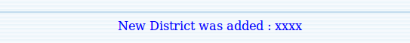Figure 4.1.3.1.2.1: successfully added district
Reason for the message :
New district has successfully added .

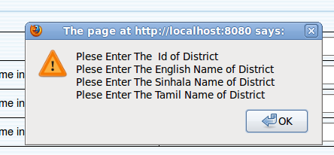Figure 4.1.3.1.2.2: missing required fields
Reason for error :
User has forgot to fill all the required fields.
How to avoid :
Fill all the required fields that need to add the distirct.

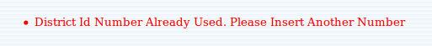Figure 4.1.3.1.2.2: id is already used

Reason for error:
The used id for the district is already used.

How to avoid :
Use a another non used id for the district.

Adding a new DS division.

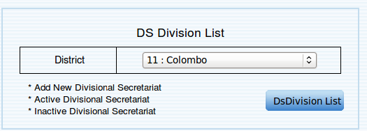Figure 4.1.3.2.1: adding a ds division home
Steps for adding a new ds division
- Select a district that where the new ds division is located .
- Click “Ds division List” button and it will load the follow page.

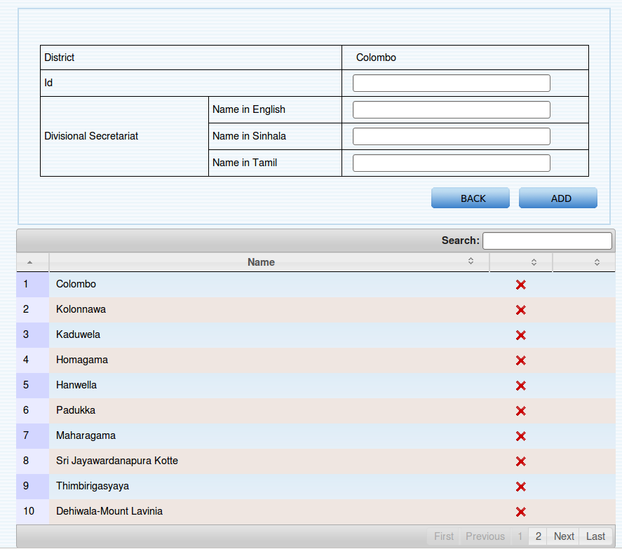Figure 4.1.3.2.2: adding a ds division
- Selected district is read only
- Enter a unique id for the ds division
- Fill name of the DS division in Sinhala and English and Tamil languages.
- To inactivate a ds division click “Wrong” symbol.
- To activate a ds division click “Correct” symbol.

Possible errors and message while adding ds division

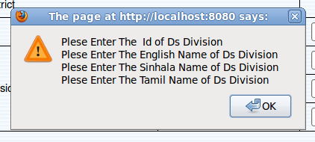Figure 4.1.3.2.1.1: fill all the required fields

Reason for error:
User must fill all the required fields .

Figure 4.1.3.2.1.2: ds id is duplicated
Reason for error :
There is another ds division with same ds division id that has entered.

Adding a new court

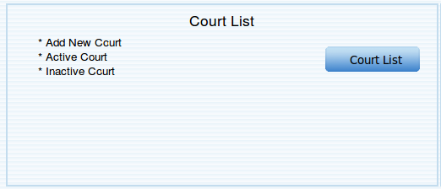Figure 4.1.3.3.1: adding a new court

By clicking on “Court List” button user can
- Add a new court to the list
- Activate or inactivate a court
- List all available courts

Steps for adding a new court to the list
- Click on the “Court List” button and it will load follow page
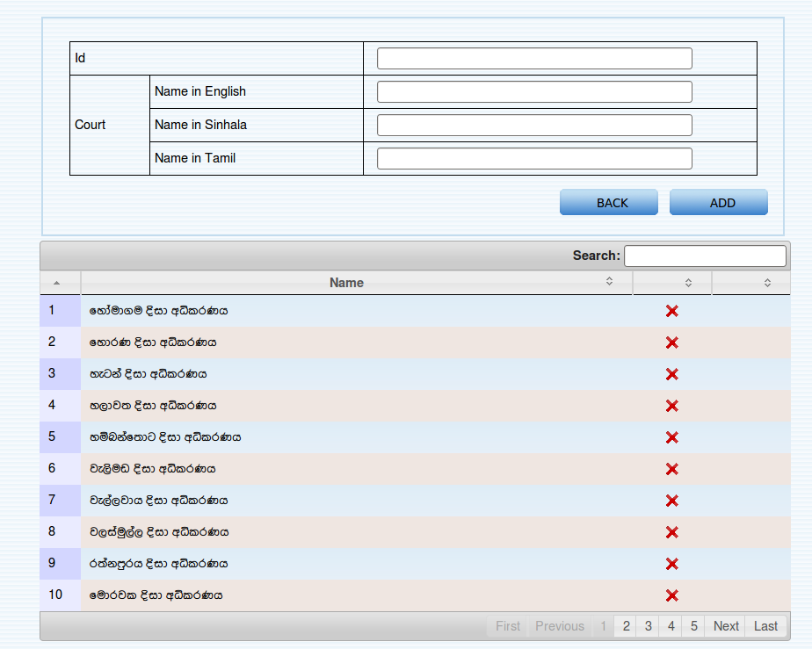Figure 4.1.3.3.2: adding a new court to the court list
- Give a unique number to the court .
- Fill court's name in Sinhala/Tamil and English .
- Click “Add” button for adding the court .
- Click “Back” button for discard all the changes .
- After successful add follow message will be displayed and that new court will be added to the list.
Figure 4.1.3.3.3: message court add successfully

Possible errors and message while adding court to the court list.

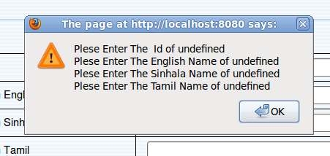Figure 4.1.3.3.1.1: fill all required fields

Reason for error
User has to fill all the required fields.

Figure 4.1.3.3.1.2: entered court id is already used

Adding a new Birth/Death Division

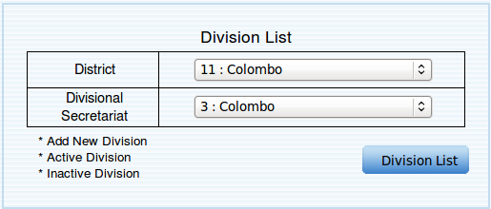Figure 4.1.3.4.1: adding a birth/death division
Steps for adding a birth/death division.
- Select a district .
- Select a d.s.division.
- Click “Division List” for add new birth/death division.
- Follow page will be displayed after clicking the button and it will contain all the existing birth/death divisions on that d.s. Division.
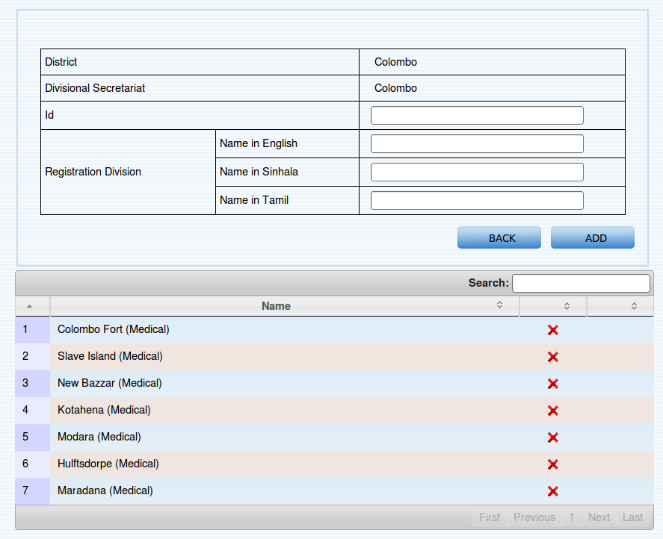Figure 4.1.3.4.2: adding a birth/death division
- Selected ds division and district is read only
- Give a Id for the birth/death division (unique to the ds division) .
- Fill name of the birth/death division in Sinhala/Tamil and English languages.
- To add the birth/death division click “Add”.
- To discard the changes that made click “Back”

Activate /Inactivate a birth/death division
- To inactivate a birth/death division click “Wrong” icon.
- To activate a birth/death division click “Correct” icon.

Possible errors and messages while adding birth/death division.

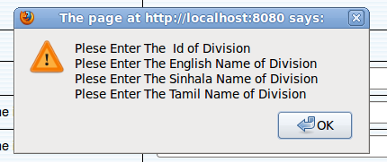Figure 4.1.3.4.2.1: fill all required fields

Reason for error :
Fill all required fields .

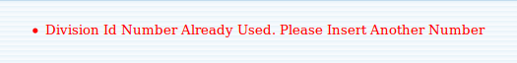Figure 4.1.3.4.2.2: division id duplicated
Reason for error:
Entered id for the division is already used for this ds division.

Adding a new Marriage registration division.

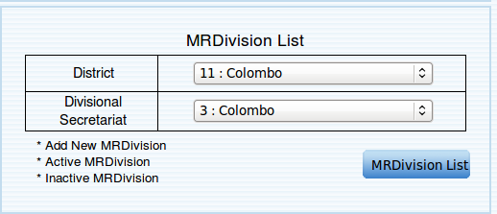Figure 4.1.3.5.1: adding a marriage registration division
Steps for adding
- Adding process is similar to adding process of birth/death divisions.

Adding a new Grama Niladhari division.

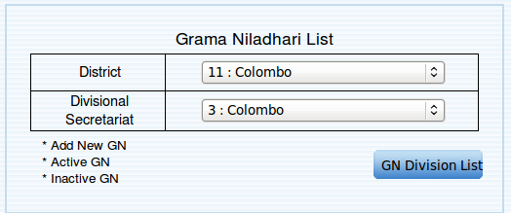Figure 4.1.3.6.1: adding a grama niladhari division

Steps for adding
- Adding process is similar to adding process of birth/death divisions.

Manage Assignments

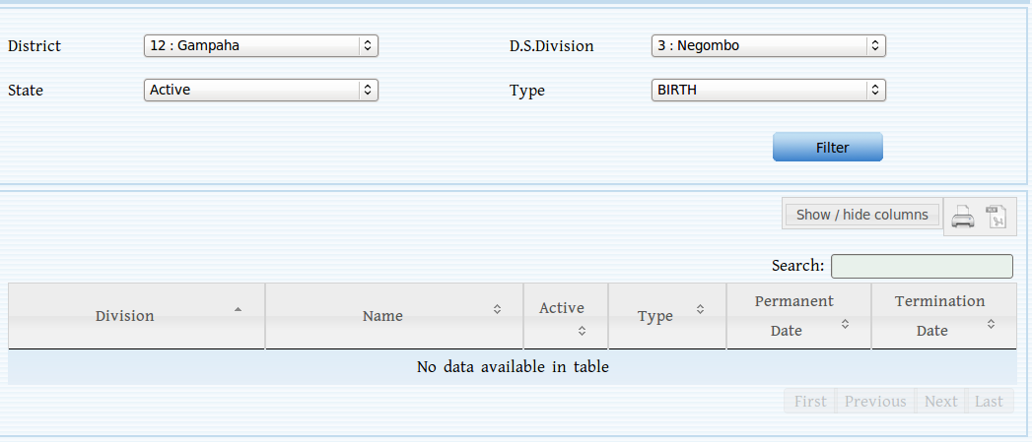Figure 4.1.4.1: manage assignments
The first district of the allowed district list, first D.S. Division of the allowed division list, active state and the birth type is automatically selected when the page is loaded.

Functionalities under this sub menu are
    - Search assignments
    - Edit registrar details
    - Add new assignments

Search Assignments

Search is based on the state and the type of the assignment.

Steps to search
    - Select the district and the D.S. Division of the assignment
    - Select the state of the assignment, whether active or inactive
    - Select the type of the assignment from 6 options (All types, kandyan marriage, general marriage, death,birth or muslim marriage )
    - Click Filter
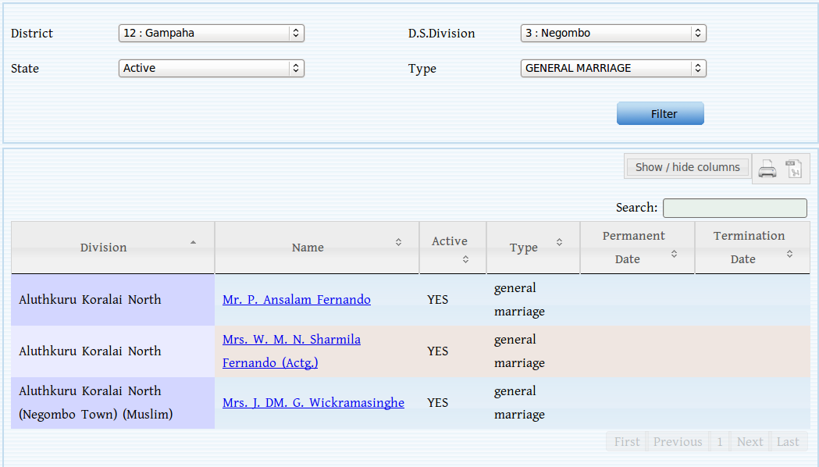Figure 4.1.4.1.1: searching a assignment
This will load all the active, general marriage assignment records in Negombo D.S.Division, Gampaha district.

Division
Division of the assignment

Name
Assigned registrar's name for the assignment

Active
Whether the assignment is active or not

Type
Type of the assignment
Can be a birth, death, general marriage, Kandyan marriage or a Muslim marriage

Permanent Date

Termination Date

Edit registrar details

Steps to edit the current details of a registrar
    - Search the record to be edited
    - Click on the name of the registrar and this will load the current details of the registrar
    - Tick in the Enable Edit Mode check box
    - Edit the details
    - Click Update
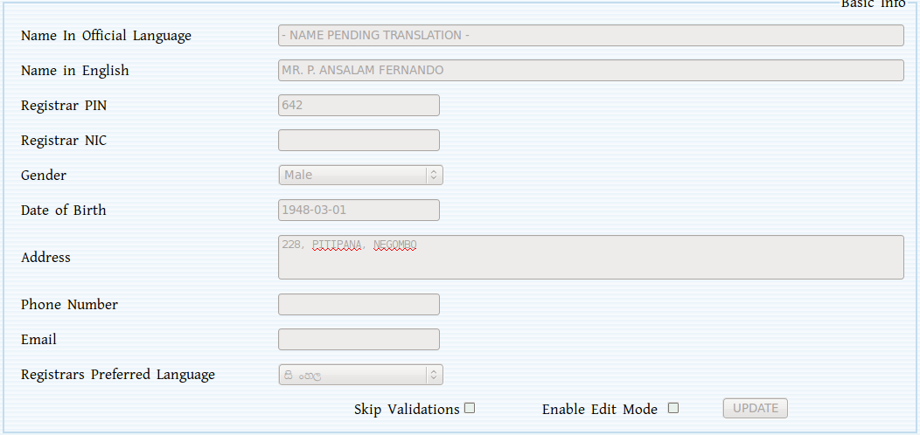Figure 4.1.4.2.1: edit registrars detail

Edit current assignments
Steps to edit
    - Search the assignment record to be edited
    - Click on the
    - Click “Veiw” icon in that row and it will display the current details of the assignment
    - Edit the details
    - Click Update

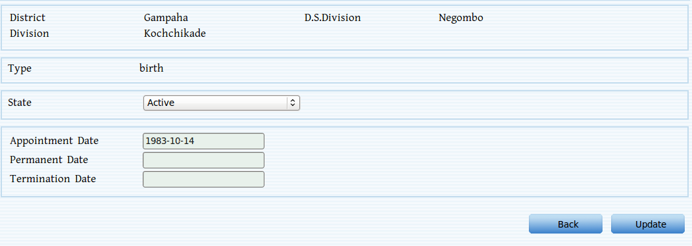Figure 4.1.4.3.1: edit assignment
Inputs and expected values

The district, D.S.Division, division and the state of the assignment are non-editable. Only the dates can be changed.

Appointment Date
Permanent Date
Termination Date

Add new assignments
New birth, death or marriage assignments can be added to registrars.

Add new assignment (Birth/Death)

Steps to add
    - Search the registrar to add new assignments (see section 4.8.3 for searching registrars)
    - Click on the name of the registrar (The loaded page shows the current assignments of the registrar)
    - Click New Assignment (Birth/Death)
    - Select the District, D.S. Division and the division of the assignment
    - Select the type of the assignment
    - Enter appointment date, permanent date and the termination date
    - Click Enter

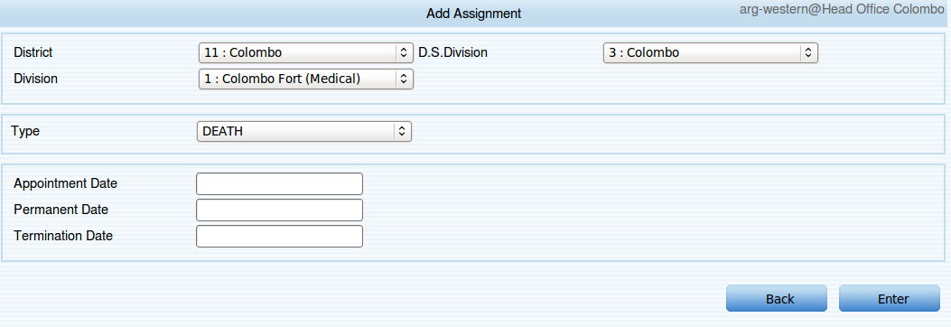Figure 4.1.4.4.1.1: add new assignment

Add new assignment (Marriage)

Steps to add
    - Search the registrar to add new assignments (see section 4.8.3 for searching registrars)
    - Click on the name of the registrar (The loaded page shows the current assignments of the registrar)
    - Click New Assignment (Marriage)
    - Select the District, D.S. Division and the division of the assignment
    - Select the type of the marriage
    - Enter appointment date, permanent date and the termination date
    - Click Enter
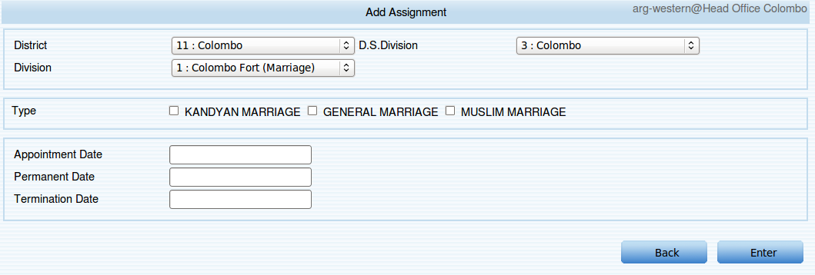Figure 4.1.4.4.2.1: adding a new assignment( marriage)

Add Registrars

To add details of a new registrar click Add Registrar in the menu and the following page is loaded.

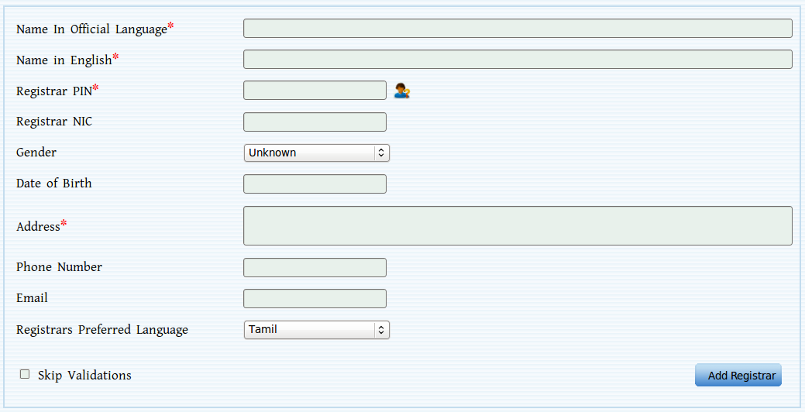Figure 4.1.5.1: adding a new registrar
Inputs and Expected values

Name in official language
    - The name of the registrar to be added

Registrar PIN
    - Must be in valid format (See section 7.6 for valid PIN number format)
    - Click on the lookup button, if the person is registered in the PRS his name in official language, name in English, NIC, gender, date of birth, address, phone number and the email fields are automatically filled

Registrar NIC
    - Must be in valid format (See section 7.5 for valid NIC format)

Gender
    - Select a value from the list

Date of Birth
    - Must be in valid date format (See section 7.2 for valid data format)

Address
Phone Number
Email
Registrars Preferred language

Click Add Registrar to complete adding a registrar. After completing the added details are displayed with the facility to add new assignments.
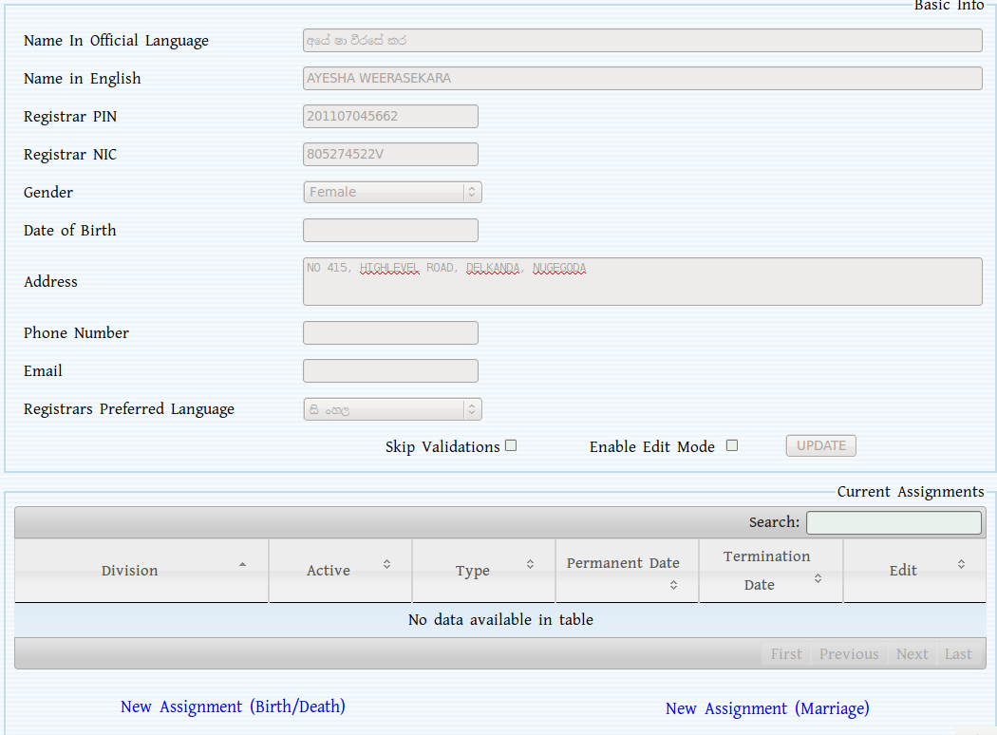Figure 4.5.1.2: after adding registrar
After completing, the added details can be changed (see section xxxx for editing) or new assignments can be added (see section xxxx for adding assignments details).

Possible errors and messages while adding a new registrar

Figure 4.1.5.1.1: already exists
Reason for the message : Registrar for the entered PIN number already exists

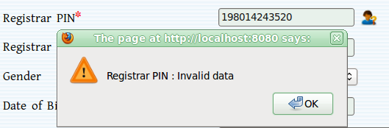Figure 4.1.5.1.2: invalid pin
Reason for the error : Entered PIN number is not in the correct format

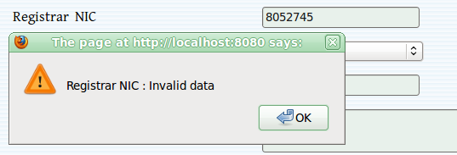Figure 4.1.5.1.3: invalid NIC
Reason for the error : Entered NIC number is not in correct format

View Events
To do

Index Records
Under this section system administrator can index the system data ( birth /death …..) and those index fill be used for PRS search functionalities.

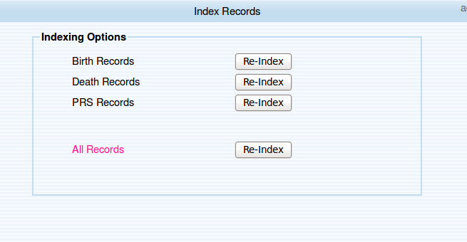Figure 4.1.7.1: indexing data
Available indexing
Index Birth Records
Use to search birth certificate and confirmation under certificate search section.
Index Death Records.
Use to search death certificate under certificate search section.
Index PRS Records .
Use for PRS person search .(this may take more time than above two)

Index All Records.
Index all above at once.

Possible errors and messages while indexing records
Figure 4.1.7.1.1: completed all record indexing

Reason for message
Successfully completed indexing all the records (birth / death /PRS)

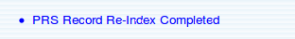Figure 4.1.7.1.2: PRS record index success

Reason for message
Successfully completed indexing PRS records.

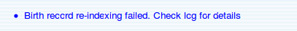Figure 4.1.7.1.3: error indexing birth records

Reason for error
Birth record indexing process had been failed.
Contact eCivil Registration support team

Figure 4.1.7.1.4: error in indexing death records

Reason for error
Death record indexing process had been failed.
Contact eCivil Registration support team

Search Registrars
To search a specific registrar click Search Registrars in the left menu.

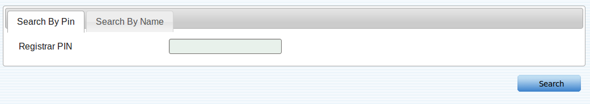Figure 4.1.8.1: search registrars
Can search a registrar by
    - PIN number
    - Name

Search by PIN number
Steps to search
    - Enter the PIN number of the registrar to be searched
    - Click Search

If successful the registrar's details and his current assignments will be loaded.

Search by name

Steps to search
    - Enter the full name or the part of the name of the registrar's
    - Click Search

If successful all the records with the entered name will be loaded.

Possible errors and messages while searching

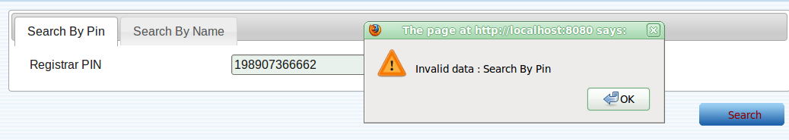Figure 4.1.8.3.1: invalid PIN number
Reason for the error :
Invalid Pin number

Figure 4.1.8.3.2: non existing
Reason for message : No registrars exist with the entered name

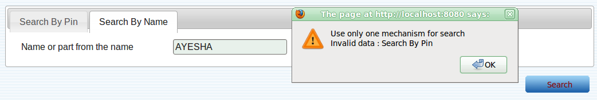Figure 4.1.8.3.3: more than one mechanism
Reason for the error : User has used more than one mechanism to search the record
How to avoid : Clear one mechanism

Report Generation
Administrator can generate various reports.
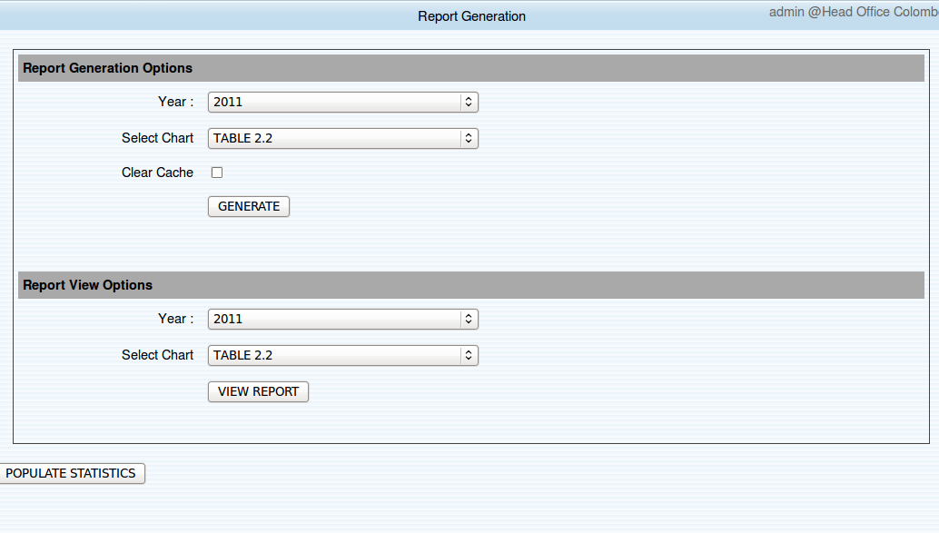

Steps for generating reports.
- Select year for the report
- Select chart type
- click “Generate” for generate the report

To view the generated report
- select year and the chart type
- click “VIEW REPORT”

populate statistics.
By clicking “Populate Statistics” administrator can generate Statistics for the user login .( statistics that user are visible at their home page”.

Possible errors and messages while generating reports.

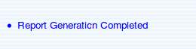Figure 4.1.9.4.1: successfully generated report

Reason for the message
Report generation was successfully completed.

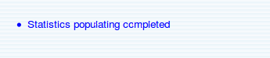Figure 4.1.9.4.2: successfully completed

Reason for the message
Statistics populating was successfully completed.

User Preference

User Preference

Changing preferred language.
User can select preferred language for the system and that can be either Sinhala or English or Tamil
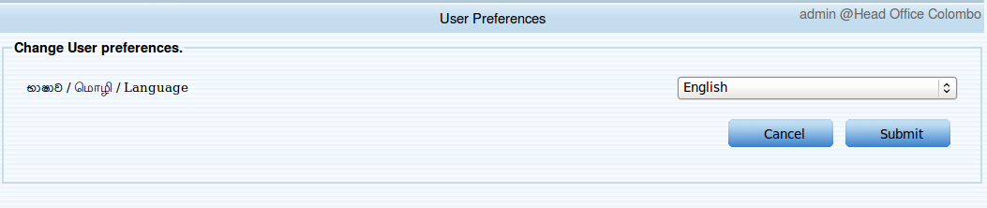
Steps for changing preferred language
Select language form the drop down list ( current preferred language is selected when load page)
- To confirm click “Submit”
- To discard changes click “Cancel”
- The total system will be change to the selected language after successfully apply.

Change Password
- This feature enable user to change user's password for login to system. It is advised to change password more frequently .
- Do not set password to easily guess one .
- Password must contain any combination of following rules.
- Password must contain at least one (1) upper case letter.
- Password must contain at least one (1) lower case letter.
- Password must contain at least one (1) number or special character.
- Password must be at least eight (8) characters in length .

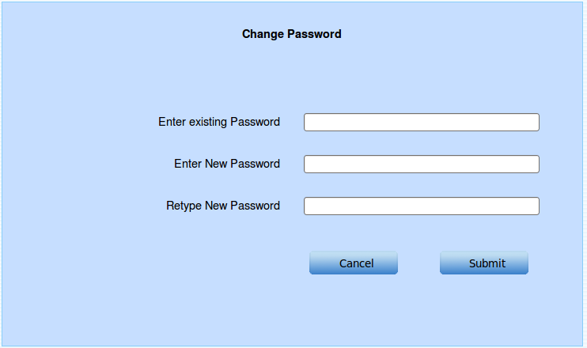Figure 4.2.2.1: changing password
Steps for changing password
- Enter existing password
- Enter new password
- Re type new password
- Click “Submit” for change or “Cancel” for cancel the operation.
- After successful password change user will be forward to user's home page .

Possible errors while changing password.

Figure 4.2.2.1: error1
Reason for error
User is unable to fill all required fields.
How to avoid
Fill all required fields.
Figure 4.2.2.2: error2
Reason for error:
Entered existing password is not match with user's existing password.
How to avoid
Re enter user's correct existing password.

Figure 4.2.2.3: error3
Reason for error:
Entered values as new password and retype new password are not equal.

Figure 4.2.2.4: error4
Reason for error :
Entered new password is not strong enough

Sample strong passwords
Password1!
123@#Pass

Icons

Edit icon |  | Approve icon
Reject icon |  | Delete icon
View icon |  | Divorce icon | 
Print icon |  | Print extract of marriage icon | 
Print extract of divorce icon |  | Person look up icon
Male party icon |  | Female party icon | 
Both party icon |  | Upload scanned image icon
 | 
 |  |  | 
 |  |  | 
 |  |  | 
 |  |  | 
 | 
 | 

Special Tools

Using date picker
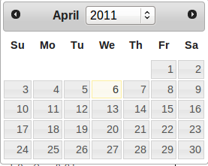Figure 6.1.1: date picker

- To select a date just click on the date .
- To change the year click on year list it will expand available years.
- To change the month click arrows

Using time picker

Figure 6.2.1: time picker

- To move hour hand click on “green “ area.
- To move minute hand click on “white” area.
- To change time format(am/pm) click on inner circle.

Using data tables

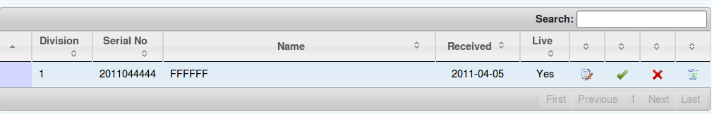Figure 6.3.1: data table
- Use “Search” to search a text inside the table.
- To navigate to next data set or previous data set click “Next” and “Last” at the bottom of the table .
- To go to first data set click “First”.
- To go to last data set click “Last” .

Valid Inputs

Serial number
- A 10 digit number
- Unique for a given birth/death/marriage division.
- Valid format yyyy{1|0}xxxxx
yyyy = current year
{1|0} = 1 for registration at DS office and 0 for registrars office
xxxxx= unique number for given birth/death/marriage division.

Sample serial numbers
2011112345
2011012345

Date
- Must be in iso8601 format (yyyy-mm-dd)
Sample dates
1986-08-21

Time
- Must be in standard 24 hrs format (HH:MM)
Sample times
15:30 for 3:30 pm
09:30 for 09:30 am

Certificate Number
- Must be a number

NIC
- Must have 9 digits and a letter
xxxxxxxxx{X|V}
xxxxxxxxx= 9 digit number
{X|V} = 10 th letter is X or V

sample NIC numbers
861234569V
563217899X

Some invalid NIC numbers
864567896V
value of digit number 3 to 5 must be in between
If NIC owner is a male that value must be between 1- 366
If NIC owner is a female that must be between 501-866

PIN
- 12 digit unique number.

Passport
- Must be less than 12 can be include numbers and characters.

